Replacing Gas Inlet Ports in the T1 Connector Block

1. | Refer to UltraFAIMS T1 User Guide to remove the connector block from the UltraFAIMS T1 interface. | 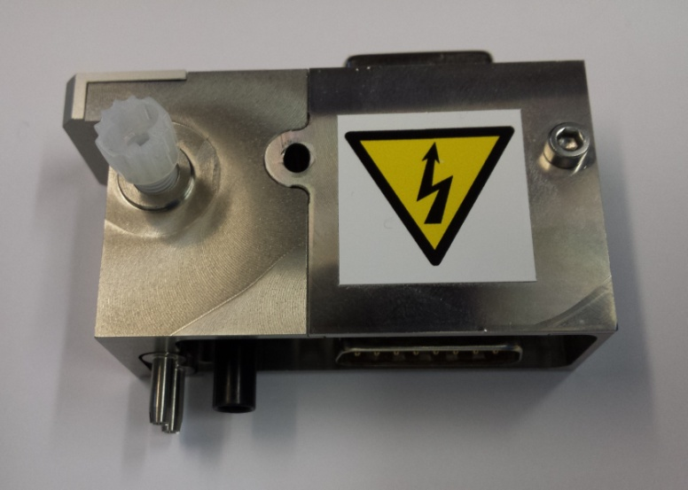
2. | Remove the gas inlet ports from the T1 adapter block, using a flat-head screwdriver to unscrew the ports as shown. | 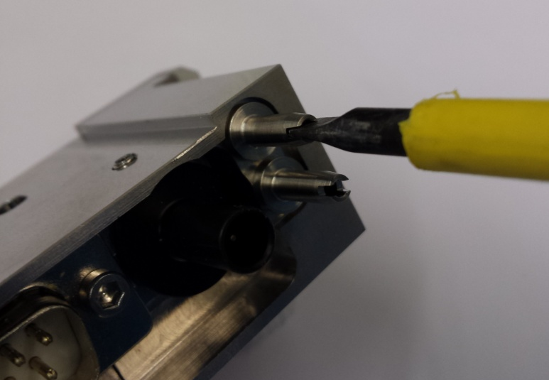
3. | Ensure the supplied o-rings are correctly positioned in the gas inlet ports. | 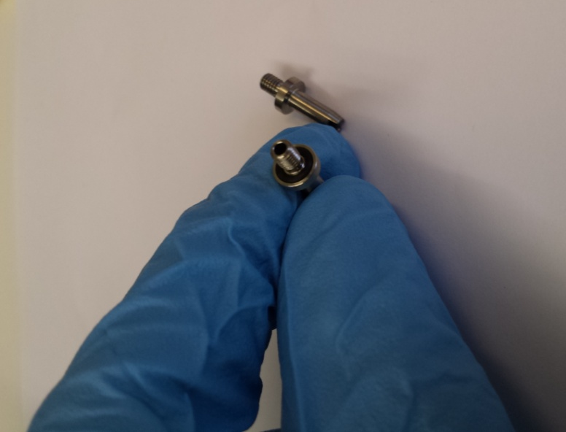
4. | Screw both of the new gas inlet ports in by hand. | 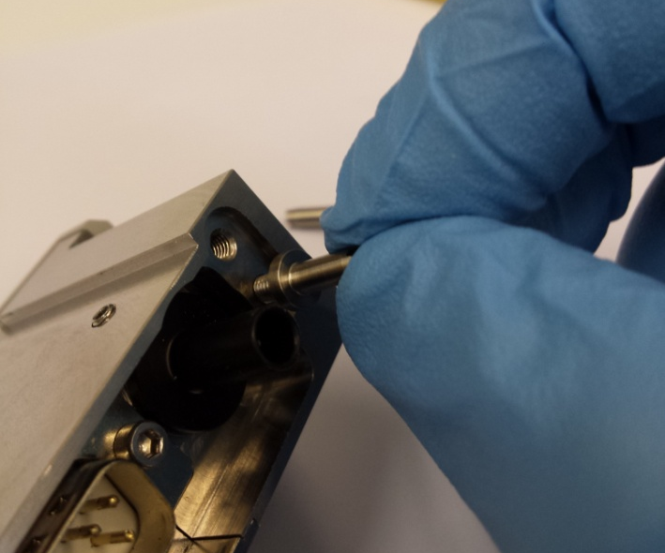
5. | Tighten the new gas inlet ports using the flat-head screwdriver (do not over-tighten). | 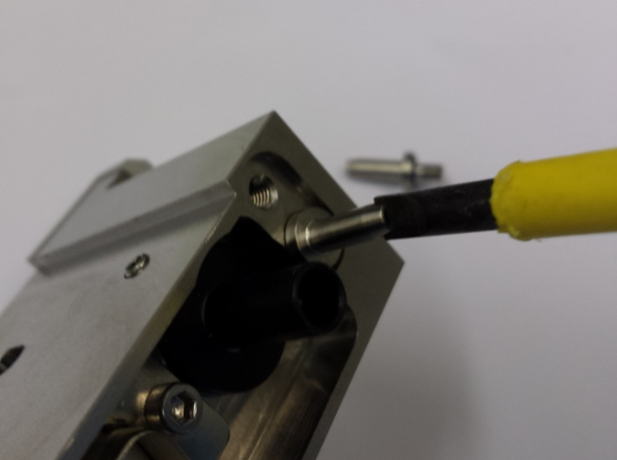
6. | Refer to UltraFAIMS T1 User Guide for reassembling the connector block with the UltraFAIMS T1 interface.

Troubleshooting
Please contact Owlstone via the support website http://support.owlstonenanotech.com or by emailing support@owlstone.zendesk.com for technical support and troubleshooting information.

