Installing and Using the Purge Automation Script

- The purge automation script automatically sets the Lonestar air purge on for half an hour, off for half an hour and so on. When running clean air through the Lonestar, this allows both the purge line inside the Lonestar and the At-Line Sampling Module to clean down.
- If it is not already on the Lonestar, save the file purge script v4.2.exe onto the desktop.

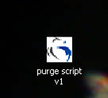

- To start the script, double click on the icon on the desktop. An icon with the Owlstone logo will appear in the system tray at the right hand side of the taskbar, at the bottom of the screen. (If the taskbar is not visible, move the mouse pointer to the bottom of the screen and it will appear.)

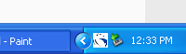

- Return to the Lonestar software.
- Once every half an hour, the script will move the mouse pointer up to the Purge button on the Lonestar dashboard and click the mouse.

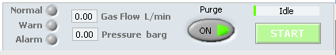

- To use the Lonestar software normally, the automation script must be paused. Right click on the icon in the system tray and a menu will appear.

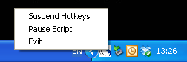

- Click on the “Pause Script” option. A tick mark should appear next to it.

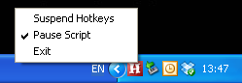

- When leaving the Lonestar overnight, turn down the flow to 0.20 l/min. The pressure does not have to be adjusted.
- Double click on the purge script icon on the desktop.
- (To open the desktop while the Lonestar software is running, first open the Start menu on the taskbar. Select My Computer from the menu. In the My Computer window, go up one level to open the desktop.)

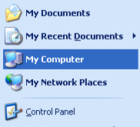

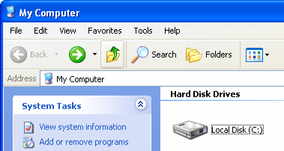

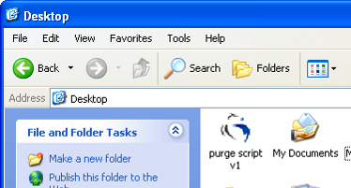

- Return to the Lonestar software and leave the Lonestar running overnight.

